**UNITED INSTITUTE OF TECHNOLOGY**

**(College Code:7145)**

**SERVERLESS IoT DATA PROCESSING**

**Team Members**

**Alex Baby D Bharath Kumar I**

**Karthika B Paul Rajan S**

**Praveen Karthick G Sharmila M**

**Mentor**

**Nishanthi - nishanthi@uit.ac.in**

# PROJECT DEVELOPMENT DOCUMENT

# Title:

**Severless IoT Data Processing**

**Project Overview:**

The Serverless IoT Data Processing project aims to develop a scalable and cost-effective system for processing and analyzing data generated by Internet of Things (IoT) devices. This project leverages serverless computing and cloud services to efficiently manage and analyze data from various IoT sources.

**Project Activities:**

**1. Set Up IBM Cloud Account:**

If you haven't already, sign up for an IBM Cloud account and log in.

**2. Create an IoT Platform:**

* Go to the IBM Cloud Dashboard.
* Create an instance of the IBM IoT Platform service.
* Follow the setup instructions to configure your IoT platform

**3. Register Smart Devices:**

* Register your smart IoT devices within the IoT platform.
* You might need to generate authentication credentials or certificates for secure device communication.

**Code Snippet:**

**const Client = require('ibmiotf');**

**const deviceConfig = {**

**"org": "your-org-id",**

**"type": "your-device-type",**

**"id": "your-device-id",**

**"auth-method": "token",**

**"auth-token": "your-auth-token"**

**};**

**const deviceClient = new Client.IotfDevice(deviceConfig);**

**deviceClient.connect();**

**4. Set Up Data Collection:**

* Configure your devices to send data to the IoT platform using MQTT or HTTP.
* Define data formats, topics, and event triggers.



**Code Snippet:**

**deviceClient.on("connect", function () {**

**setInterval(function () {**

**const data = {**

**temperature: Math.random() * 100,**

**humidity: Math.random() * 100**

**};**

**deviceClient.publish("status", "json", JSON.stringify(data));**

**}, 5000); // Send data every 5 seconds**

**});**

**5. Set Up IBM Cloud Functions:**

* Create a new action within IBM Cloud Functions to process incoming IoT data.
* Write the code for data processing using Node.js, Python, or any supported language.

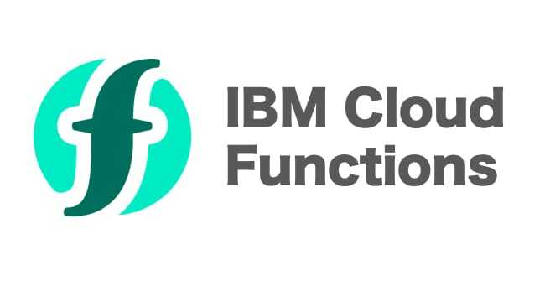

**Code Snippet:**

**function main(params) {**

**return { message: "Hello, IBM Cloud Functions!" };**

**}**

**6. Connect IoT Platform to IBM Cloud Functions:**

* Create a trigger that connects the IoT platform to your IBM Cloud Function.
* Specify the events or conditions that trigger the function

**Conclusion:**

Serverless IoT for data processing offers a promising and efficient approach to handling the vast amount of data generated by IoT devices. By leveraging serverless computing, organizations can scale dynamically, reduce operational overhead, and focus on application development rather than infrastructure management. However, it's essential to carefully consider the specific use case, security, and cost implications when implementing serverless IoT solutions. When done right, serverless IoT can significantly enhance real-time data processing, analytics, and decision-making in the IoT ecosystem.